**Social Classes**

**Sociology Research**

***Ibrahim Abou Zahr***

**Understanding Social Classes**

Sociologists have long recognized the significance of social classes in shaping individuals' experiences and opportunities. While the exact number and names of social classes vary across societies, the fundamental concept remains the same: people are stratified based on their wealth, power, and prestige. This paper will explore the historical and contemporary relevance of social classes, with a particular focus on the middle class and the importance of maintaining a balanced class structure.

**Defining Social Classes**

Before delving into the specifics, it's essential to define what constitutes a social class. Sociologist Max Weber identified three components of stratification: class (economic position), status (prestige), and party (power). These factors combine to create a complex system of inequality. In modern Western societies, we typically identify three main social classes: upper, middle, and lower. The upper class consists of the extremely wealthy, often through inheritance. The middle class, which this paper will focus on, includes professionals, managers, and small business owners. The lower class comprises low-wage workers and the unemployed.

Within these broad categories, there is further stratification. For example, the upper class can be divided into **old money** (inherited wealth) and the **nouveau riche** (those who have gained wealth through their own efforts). Similarly, the middle class includes both white-collar workers (like managers and professionals) and blue-collar workers (like skilled tradespeople). These nuances are important for understanding the lived experiences of individuals within different social classes.

**Historical Examples of Social Classes**

Throughout history, social classes have played a pivotal role in shaping societies. Ancient civilizations, such as Greece and Rome, had clear divisions between slaves, freemen, and aristocrats. The feudal system of medieval Europe further solidified class distinctions, with monarchs, nobles, clergy, vassals, and serfs each having defined roles and social mobility was limited.

**The Rise of the Middle Class**

The Industrial Revolution marked a significant shift in social classes. As manufacturing and trade expanded, a new middle class emerged. This group, composed of business owners, managers, and professionals, gained economic and political power. The middle class played a crucial role in shaping modern democracy, advocating for rights and representation.

The growth of the middle class was also driven by changes in education and technology. As access to education expanded, more people were able to acquire the skills needed for white-collar jobs. Technological advancements created new industries and job opportunities, further fueling middle-class growth.

**Contemporary Examples and Importance of the Middle Class**

In contemporary societies, the middle class remains vital. As Erik Olin Wright argues, the middle class acts as a buffer, preventing extreme polarization between the rich and the poor. A robust middle class can promote social mobility, political stability, and economic growth. However, there are concerns that the middle class is shrinking in many countries, potentially leading to increased inequality and social unrest.

**Importance of Balance Among Social Classes**

While the middle class plays a unique role, it's essential to recognize the importance of all social classes. A balanced class structure allows for the division of labor, innovation, and cultural diversity. The upper class often drives economic investment and philanthropy. The lower class performs essential jobs and can be a source of social change, as seen in movements for workers' rights. However, extreme inequality between classes can lead to conflict and societal instability. Inequality between classes, disrupts the social balance and will eventually lead to conflict.

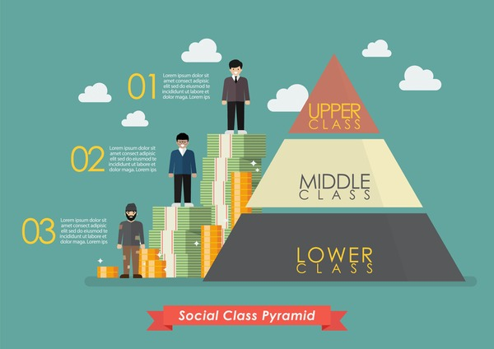

**Maintaining Balance and Promoting Mobility**

To ensure a healthy and functioning society, it's crucial to maintain a balance among social classes and promote mobility. Policies like progressive taxation, access to quality education, and fair labor laws can help reduce inequality and provide opportunities for advancement. As Grusky and Ku argue, addressing poverty and expanding the middle class are key to promoting social inclusion and cohesion.

**Communism, Marxism, and Social Classes**

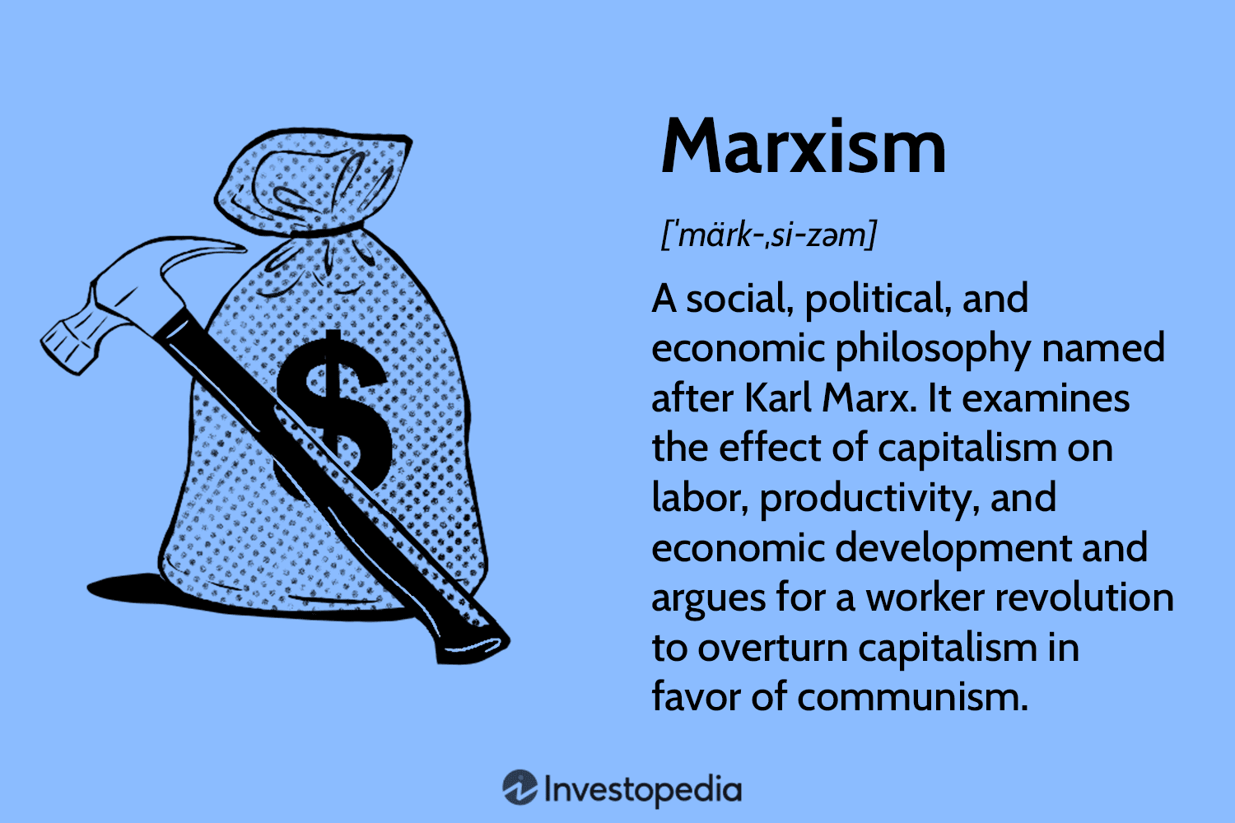

Communist and Marxist theories offer a distinct perspective on social classes, emphasizing the role of economic exploitation and class conflict. According to Karl Marx, class is determined by one's relationship to the means of production. Under capitalism, there are two primary classes: the bourgeoisie (those who own the means of production) and the proletariat (those who must sell their labor). Marx argued that the bourgeoisie exploit the proletariat, creating alienation and class consciousness among workers. He predicted that this would eventually lead to a revolution, overthrowing the capitalist system and establishing a communist society without classes.

Marxism has had a profound impact on the study of social classes, highlighting issues of economic inequality and power imbalances. However, critics argue that Marxist theory oversimplifies the complexity of social stratification, failing to account for the emergence of the middle class and the nuanced divisions within classes. Despite these limitations, Marxist concepts remain influential in sociological analyses of class and inequality.

Marxist theory has been influential not only in the development of communism but also in shaping sociological thought more broadly. Concepts like false consciousness (when workers misunderstand their true interests and support the capitalist system) and the labor theory of value (which argues that the value of goods comes from the labor used to produce them) remain important in analyses of class and inequality.

**Communist Ideals and Classlessness**

Communist theory envisions a classless society, where the means of production are collectively owned and resources are distributed based on need. In practice, however, communist states have often created new systems of stratification, with the ruling party elite holding power and privileges. This highlights the challenges of achieving true social equality and the persistence of social classes even in systems aiming to eliminate them.

**Social Class Conflicts: A Historical and Contemporary Perspective**

Social classes have long been a source of conflict, with struggles over resources, power, and status driving social change. This section will explore examples of class conflict throughout history and in contemporary societies, highlighting the ongoing relevance of social class in shaping social dynamics.

**Historical Examples of Class Conflict**

The French Revolution (1789-1799) is a classic example of class conflict, with the peasantry and middle class rising against the aristocracy and monarchy. This revolution, fueled by Enlightenment ideals of equality and liberty, led to the execution of King Louis XVI and the establishment of the First French Republic.

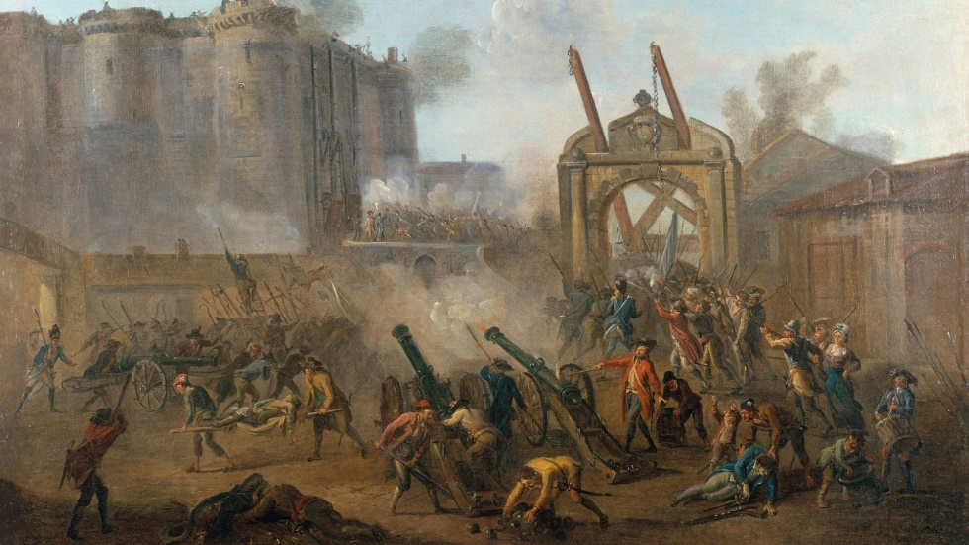

In the 19th and early 20th centuries, the labor movement emerged as a response to the exploitation of workers during the Industrial Revolution. Strikes, protests, and the formation of unions were key strategies used by the working class to demand better wages, working conditions, and rights. These class conflicts led to significant reforms, including the eight-hour workday and workers' compensation.

**Contemporary Examples of Class Conflict**

In contemporary societies, class conflict often takes less overt forms but remains a powerful force. The Occupy Wall Street movement, which began in 2011, highlighted issues of economic inequality and the power of the "1%" versus the "99%." While not leading to revolution, the movement brought attention to wealth disparities and the influence of the financial elite.

The Yellow Vest protests in France, starting in 2018, offer another example of class conflict. Initially sparked by fuel tax increases, the protests grew into a broader movement against economic insecurity and the perceived disconnect between the ruling class and the working and middle classes.

Another great example is the situation in Lebanon in which took the all social classes by storm. Due to the severe economic crisis, the Lebanese middle class sector was devastated. The collapse of the Lebanese Lira, hyperinflation, and job losses have pushed many middle class people into near poverty or full on poverty. This in return created a gap between the lower class sector and upper class.

Moreover, the decline of the middle class in Lebanon has had its political consequences. The imminent loss of this buffer between the rich and the poor has led to widespread social unrest and discomfort between the citizens. Protests took place during the 2019 (**Thawra**) in which the Lebanese people tried to voice their pain with the dire economic situation.

The Lebanese situation highlights the importance of economic stability in which supports the middle class. Such measures include banking protection policies, job creations, quality education and social mobility. In the absence of such policies, the middle class is gone, leading to a wide range of negative effects both economically and politically.



**Class Conflict and Social Change**

As these examples illustrate, class conflict has been a driver of social change throughout history. While often accompanied by struggle and instability, class conflict can lead to reforms and greater equality. However, achieving lasting change requires addressing the underlying structural issues of economic inequality and power imbalances.

In contemporary societies, class conflict may take the form of political polarization, with different classes having distinct interests and worldviews. Understanding and addressing these class divisions is crucial for building a more equitable and just society.

**Conclusion**

Social classes remain a fundamental aspect of societies, shaping individuals' experiences and opportunities. While the exact structure may vary, the importance of maintaining a balance among classes and promoting mobility is clear. The middle class plays a crucial role in promoting stability and growth, but all classes contribute to the functioning of society. As we move forward, it's essential to address issues of inequality and work towards creating a more just and equitable social structure.

**References**

Grusky, D., & Ku, M.-C. (2017). The concept of social inclusion and the policies for social inclusion. Annual Review of Sociology, 43, 279-298.

Olin Wright, E. (2010). Envisioning real utopias. Verso Books.

Weber, M. (1922). Economy and Society: An Outline of Interpretive Sociology. University of California Press.